**5.3 fetch-execute cycle**

**Name ___________ class_____________**

**1**

The table shows six stages in the von Neumann fetch-execute cycle.

Put the stages into the correct sequence by writing the numbers 1 to 6 in the right hand column.

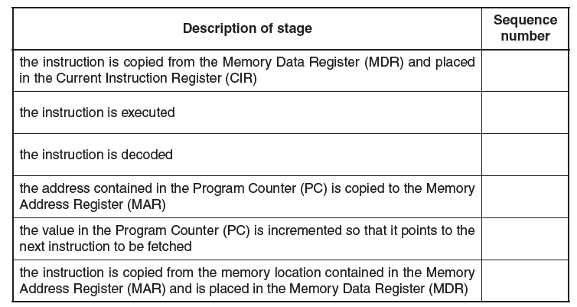

**2**

**(a)** Describe how special purpose registers are used in the fetch stage of the fetch-execute cycle.

_________________________________________________________________

_________________________________________________________________

_________________________________________________________________

_________________________________________________________________

_________________________________________________________________

_________________________________________________________________

_________________________________________________________________

**(b)** Use the statements A, B, C and D to complete the description of how the fetch-execute cycle handles an interrupt.

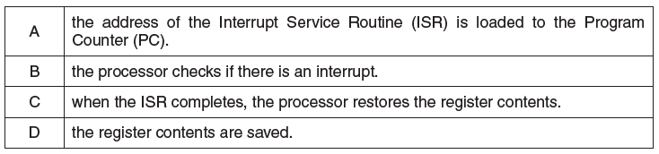

At the end of the cycle for the current instruction__________________ .

If the interrupt flag is set, _____________,____________and ______________

The interrupted program continues its execution.

**3**

A student has written the steps of the fetch stage of the fetch-execute (FE) cycle in register transfer

notation. The student has made some errors.

Line 1 MDR [PC]

Line 2 PC PC + 1

Line 3 MDR [MAR]

Line 4 CIR PC

**(a)** Identify the line numbers of **three** errors that the student has made. Write the correct notation for each error.

**Line number of error Correct notation**

**(b)** One stage of the FE cycle includes checking for interrupts.

**(i)** Give **three** different events that can generate an interrupt.

1 ....................................................................................................................................

2 ....................................................................................................................................

3 .....................................................................................................................................

**(ii)** Explain how interrupts are handled during the fetch-execute cycle.

.......................................................................................................................................

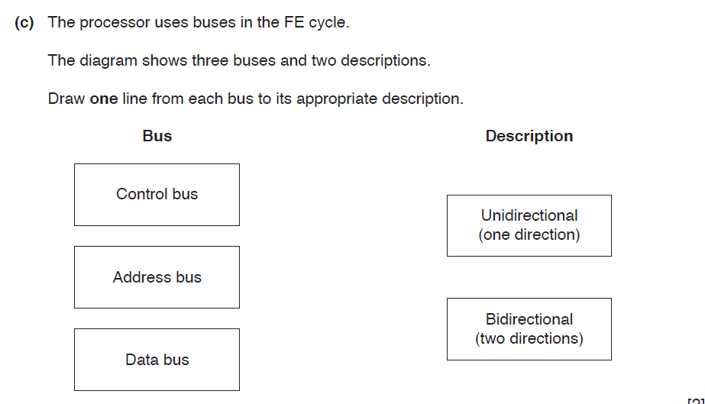

**4**

The Von Neumann model uses a series of registers.

**(a)** Explain what is meant by the term **register**.

.......................................................................................................................................

.......................................................................................................................................

.......................................................................................................................................

.......................................................................................................................................

**(b) (i)** Explain the purpose of the Memory Data Register (MDR).

.......................................................................................................................................

.......................................................................................................................................

.......................................................................................................................................

.......................................................................................................................................

**(ii)** Name **two** registers, other than the MDR, that are used in the fetch-execute cycle.

Register1

..........................................................................................................................

Register2

..........................................................................................................................

**(c)** X is a register. The current contents of X are:

1 0 0 0 0 1 1 1

**(i)** The current contents of register X represent an unsigned binary integer.

Convert the value in X into denary.

.......................................................................................................................................

**(ii)** The current contents of register X represent a Binary Coded Decimal.

Convert the value in X into denary.

.......................................................................................................................................

**(iii)** The current contents of register X stores a two’s complement binary integer.

Convert the value in X into denary.

.......................................................................................................................................

**5**

The sequence of operations shows, in register transfer notation, the fetch stage of the fetchexecute

cycle.

1 MAR ← [PC]

2 PC ←  [PC] + 1

3 MDR ←  [[MAR]]

4 CIR ←  [MDR]

• [register] denotes contents of the specified register or memory location

• step 1 above is read as “the contents of the Program Counter are copied to the Memory

Address Register”

**(i)** Describe what is happening at step 2.

.......................................................................................................................................

......................................................................................................................................

**(ii)** Describe what is happening at step 3.

.......................................................................................................................................

.............................................................................................................................

**(iii)** Describe what is happening at step 4.

.......................................................................................................................................

......................................................................................................................................

**(c)** Describe what happens to the registers when the following instruction is executed:

LDD 35

.......................................................................................................................................

**(d)**

**(i)** Explain what is meant by an interrupt.

.......................................................................................................................................

...................................................................................................................................... **(ii)** Explain the actions of the processor when an interrupt is detected.

.......................................................................................................................................

.......................................................................................................................................